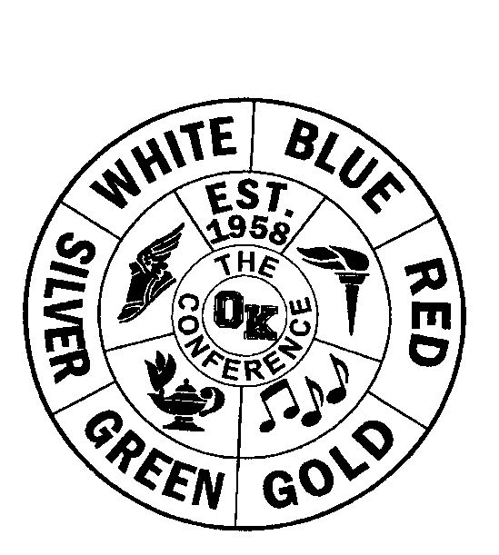
OK Conference All-Conference

Sport: Boys Bowling

Division: Silver

School Year: 2020-21

AD Name: Adam Valk

1ST TEAM HONORABLE MENTION

Name/Gr School Name/Gr School
Wyatt Meyers | Belding |  | Alex Chavez | Kelloggsville
Trent Altman | Belding |  | Josh Tripp | Hopkins
Joel Pablo | Lee |  | Nolan Werkhoven | Calvin Christian
Joseph Timmer | Calvin Christian |  | Brendan Welch | Sparta
Reuben VanderKodde | Calvin Christian |  | Brennan Horrigan | Sparta
Ka’von Cann | Godwin |  | Aiden Kelly | Comstock Park
Kaleb Rowland | Sparta
Andrew Iler | Sparta
Sam Woolworth | Sparta
Andrew Wohlford | Comstock Park
Jack Wohlford | Comstock Park

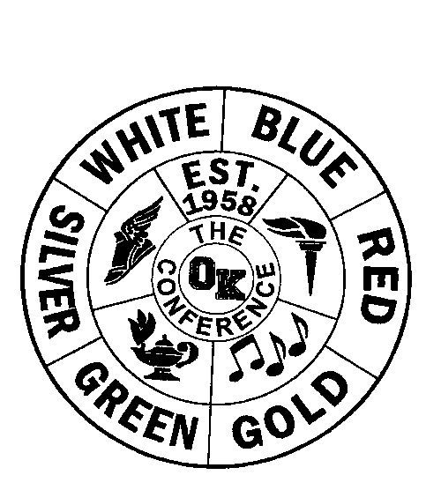
OK Conference Final Standings

Sport: Boys Bowling

Division: Silver

School Year :2020-21

AD Name: Adam Valk

Regular Season Conference Tournament
School Record Pts. Place School Pts. Place
Sparta | 14-1 | 14 |  |  | Belding | 8 | 1st
Belding | 13-1 | 13 |  |  | Sparta | 7 | 2nd
Comstock Park | 10-6 | 10 |  |  | Comstock Park | 6 | 3rd
Calvin Christian | 11-4 | 11 |  |  | Godwin | 5 | 4th
Hopkins | 7-8 | 7 |  |  | Lee | 4 | 5th
Lee | 5-11 | 5 |  |  | Kelloggsville | 3 | 6th
Godwin | 4-11 | 4 |  |  | Hopkins | 2 | 7th
Kelloggsville | 3-12 | 3 |  |  | NPC | 1 | 8th
NPC | 0-14 | 0 |  |  | Calvin Christian | 0 | 9th

Final Standings
School Place Pts.
Sparta | 1st | 21
Belding | 1st | 21
Comstock Park | 3rd | 16
Calvin Christian | 4th | 11
Hopkins | 5th | 9
Lee | 5th | 9
Godwin | 5th | 9
Kelloggsville | 8th | 6
NPC | 9th | 1

