OK Conference All-Conference  Sport ______Girls Track  Division ____Silver_________  School Year _____2020-21  AD Name ____Joel Wilker | 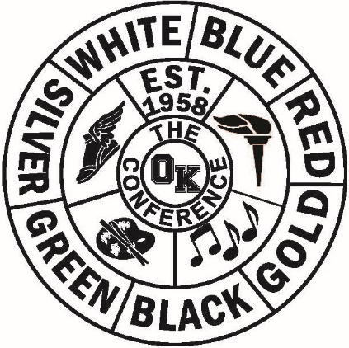

Name/Gr School Name/Gr School
Mallory Wright | Belding |  | Emily Heintzelman |  | Comstock Park
Eliot Ross | Belding |  | Shan’thony Taylor |  | Comstock Park
Brooklyn German | Belding |  | Mackenzie Heintzelman |  | Comstock Park
Julia Finley | Belding |  | Lauren Peoples |  | Comstock Park
Ashtyn Cegelis | Belding |  | Emily Bussert |  | Comstock Park
Brook Simpson | Belding |  | Ja’Kaya Lay |  | Godwin
Rylie Bjorkman | Sparta |  |  | Nhojaray Offray | Godwin
Paige Wilson | Sparta |  | Shlique Box |  | Godwin
Kennedi Wood | Sparta |  |  | Kashaari Babb | Godwin
Madyson Oudbier | Sparta |  |  | Kierra Stimoff | Godwin
Samantha Huizen | Sparta
Allyson DeKome | Sparta
Trinity Skowronek | Sparta
Jocelyn Garza | Sparta
Helena Kerber | Hopkins
Grace Brenner | Hopkins
Catherine Kortman | Calvin Christian
Hanna Kroeze | Calvin Christian
Leanne Krombeen | Calvin Christian

OK Conference All-Conference

Sport ______Girls Track

Division ____Silver_________

School Year _____2020-21

AD Name ____Joel Wilker_______

Dual Season Final Standings
School Record Pts School Place Pts
Sparta | 8-0 | 9 |  | Belding | 1st | 17
Belding | 7-1 | 8 |  | Sparta | 1st | 17
Calvin Christian | 6-2 | 7 |  | Calvin Christian | 3rd | 14
Hopkins | 5-3 | 6 |  | Hopkins | 4th | 11
Comstock Park | 4-4 | 5 |  | Comstock Park | 4th | 11
Kelloggsville | 3-5 | 4 |  | Godwin | 6th | 7
Godwin | 1-7 | 3 |  | Kelloggsville | 6th | 7
NorthPointe Christian | 0-8 | 2 |  | North Pointe Christian | 8th
Lee | 0-5 | 1 |  | Lee | 8th

Conference Finals Results
School Place Pts
Belding | 1st | 9
Sparta | 2 | 8
Calvin Christian | 3 | 7
Comstock Park | 4 | 6
Hopkins | 5 | 5
Godwin | 6 | 4
Kelloggsville | 7 | 3

